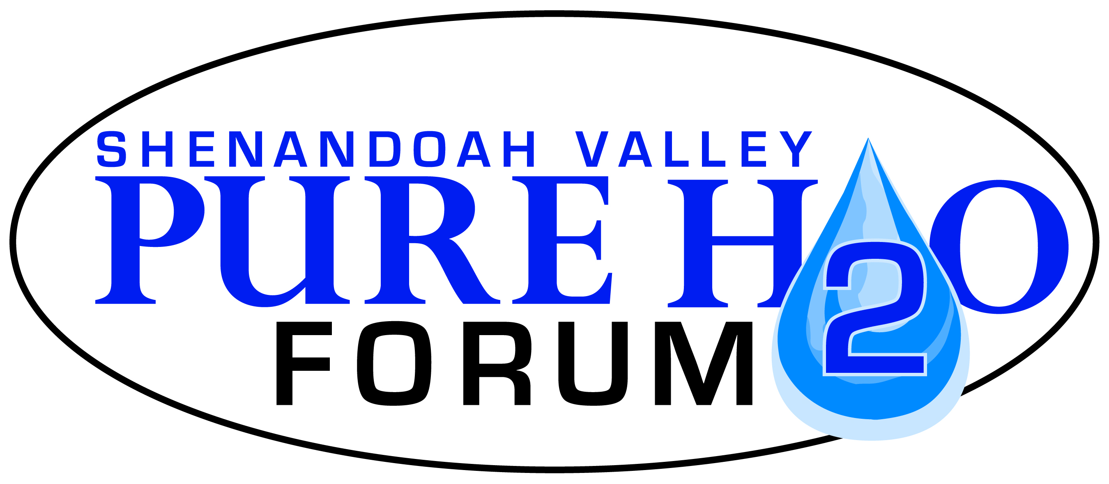
Please submit completed application to:
Shenandoah Valley Pure Water Forum, Inc.
PO Box 72
Harrisonburg, VA 22803

www.purewaterforum.org

PURE WATER FORUM GRANT APPLICATION ($501- $1,000)

Requesting Organization
Name:
Address:
Is your organization a member of the Pure Water Forum: Yes No
Please provide a description of your organization (type of organization, purpose). Include descriptions of any past related projects you have completed.
Project Coordinator
Name, Title:
Address:
Phone number:
Email address:
Project Information
Please provide a description of the proposed project. Include project objectives, activities, location, target audience and partners. Note how your project supports the mission of the Pure Water Forum and the priorities of the Grant Program. Explain how the Pure Water Forum’s contribution to this project will be recognized.
Total requested funding: | $ | Total project cost: |  | $
Please provide a project budget below.
Personnel: provide an itemized personnel budget including position titles, hours and hourly rates for employees working on the project.
 |  |  | Personnel Subtotal: $
Supplies: provide an itemized supplies budget including meeting materials, refreshments, materials for tree plantings and other activities.
 |  |  | Supplies Subtotal: $
Travel: provide a detailed travel budget including miles traveled and mileage rates ($0.535/mile), lodging, conference registration fees, tuition expenses, and meals during travel.
 |  |  | Travel Subtotal: $
Contractual: provide an itemized contractual budget including any payments for contractual services such as engineering design work, construction equipment operation, brochure design and printing etc.
 |  |  | Contractual Subtotal: $
Please provide an anticipated schedule for your project below. Indicate when specific project tasks will be completed, not to exceed 1 year.
Please describe any plans for continuing support for this project beyond the period of the Pure Water Forum Small Grant period. Include funding sources and expected project activities.

