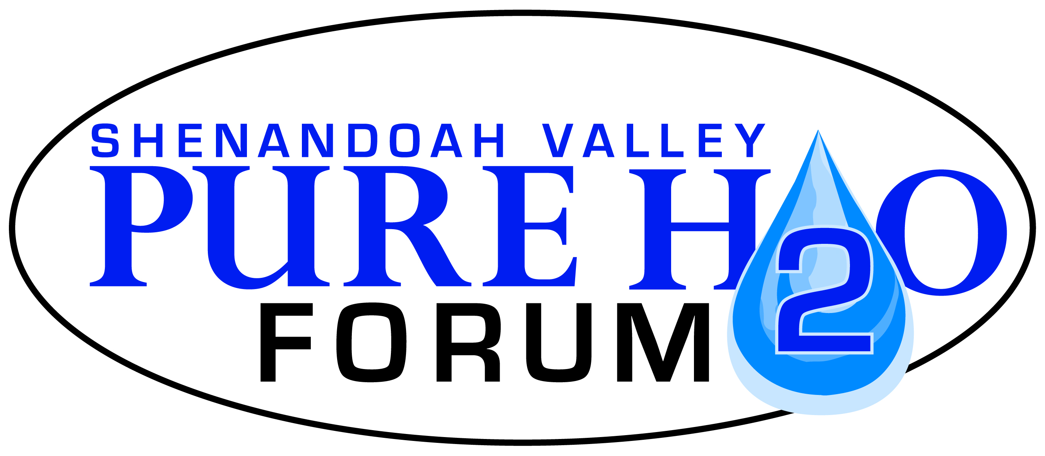
Please submit completed application to:
grants@purewaterforum.org

Shenandoah Valley Pure Water Forum, Inc.
PO Box 72
Harrisonburg, VA 22803

www.purewaterforum.org

Pure Water Forum Scholarship

The Pure Water Forum scholarship is open to any student who resides in the Shenandoah Valley Watershed. The scholarship can cover half of the tuition of the camp or class with a maximum of five hundred dollar scholarship.

The guidelines for consideration of the scholarship include:
- Camps or classes that last a minimum of three to five days.
- Camps, courses, or classes that would correlate to our mission statement or objectives.

Scholarships are distributed by the end of the month.

Application

Name:

Address:

City: State: Zip:

Email:

Phone:

Camp/Class website:

Camp/Class dates:

Camp/Class description:

Reference:

Essay
Why do you want to go to this camp or take this class? The essay should be hand written and then either scanned or mailed to the Pure Water Forum.
Reflection post camp or class

Please submit one or two pictures and paragraph that highlights your experience.

Also, please fill out your camp or class report card.

Did you feel safe at the camp or class? YES NO

Was the camp or class fun and engaging? YES NO

Was the camp or class organized? YES NO

What was the most important or relevant thing you learned about the environment from the class or camp?

Would you attend this camp or class again or would you recommend it to a friend? YES NO

