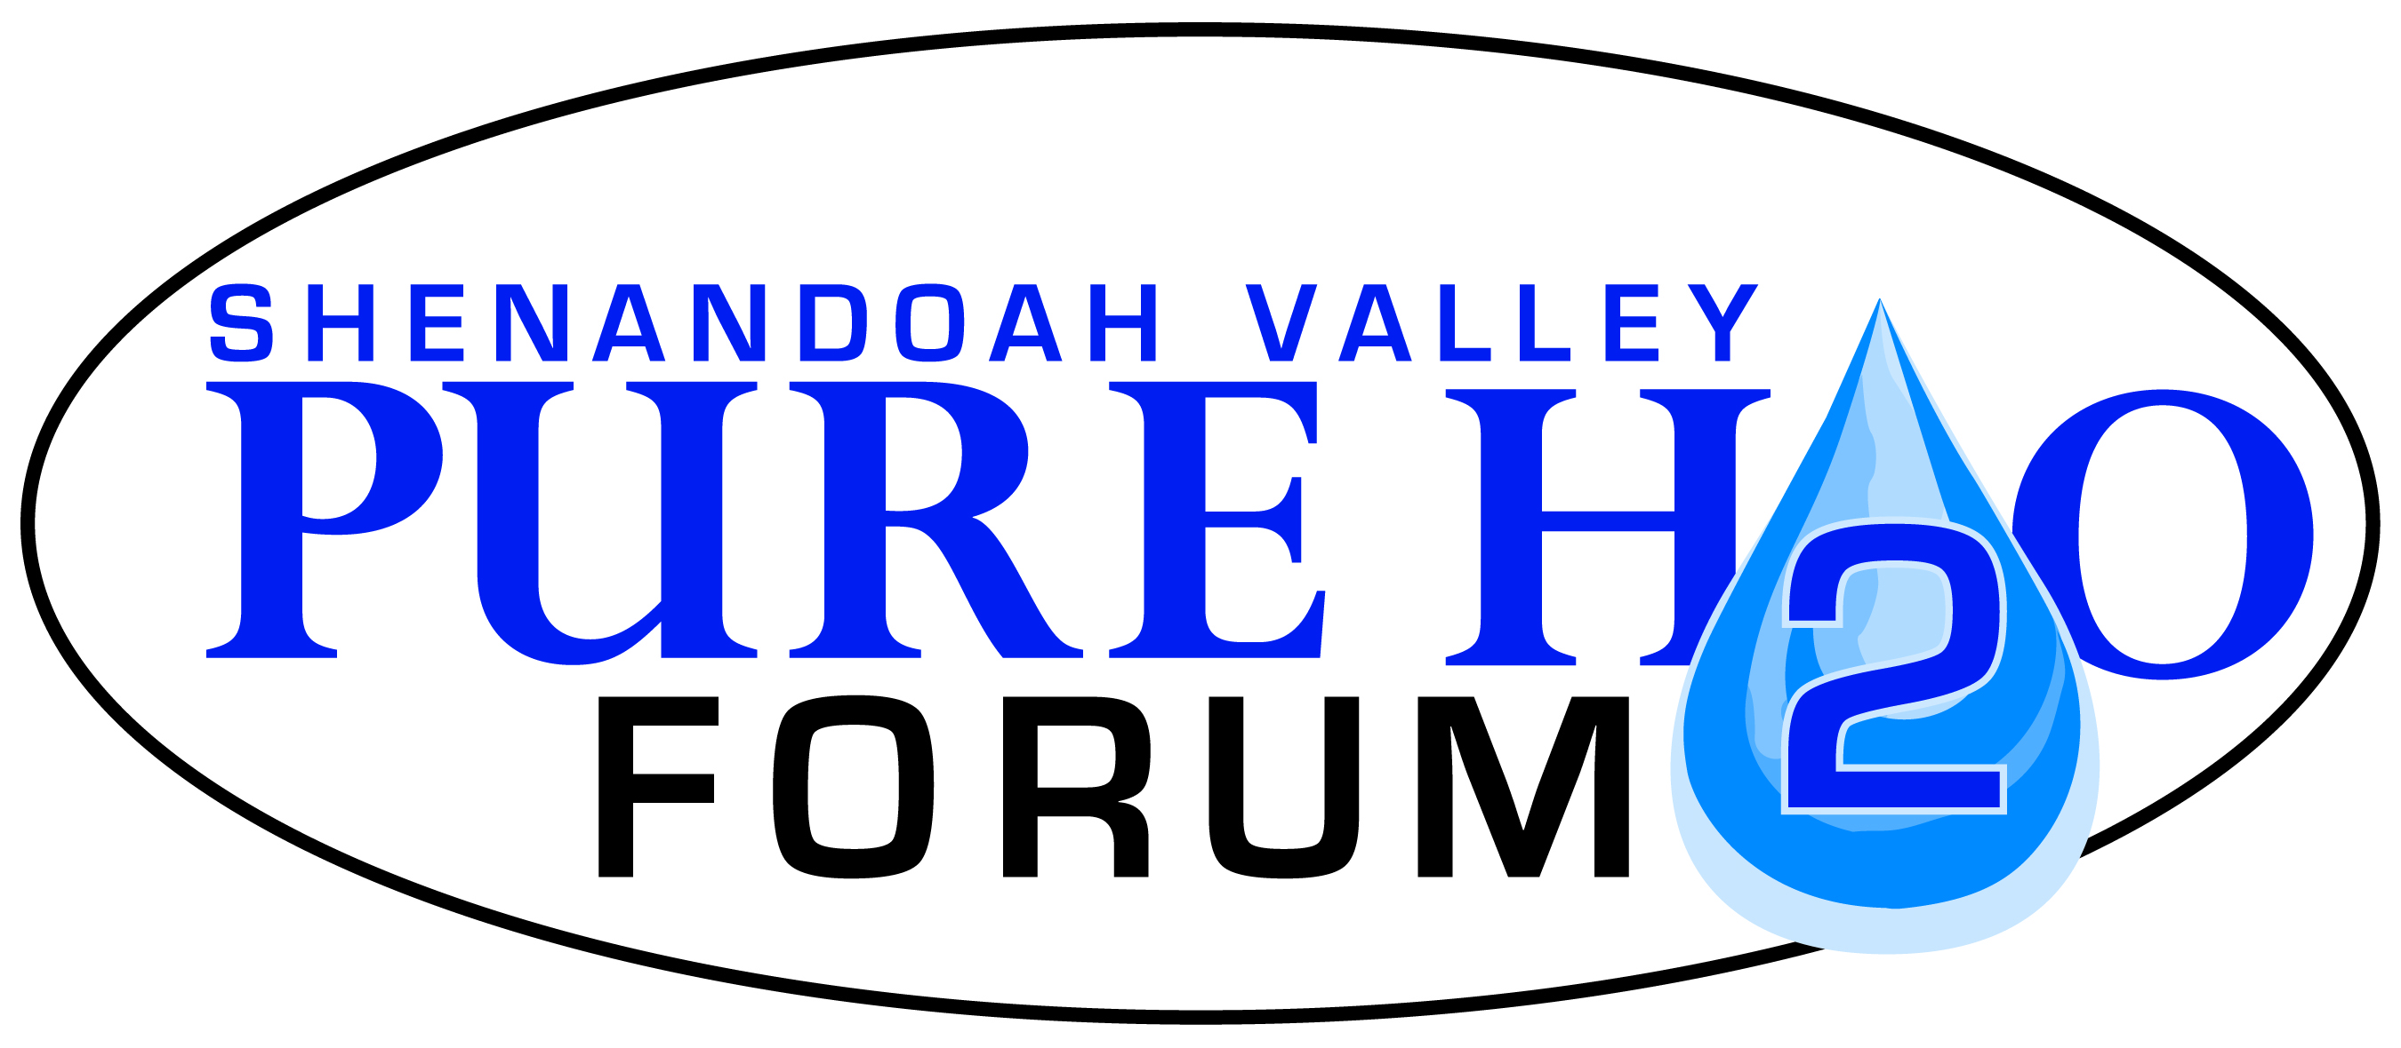
Please submit completed application to:
Shenandoah Valley Pure Water Forum, Inc.
PO Box 72
Harrisonburg, VA 22803

www.purewaterforum.org

PURE WATER FORUM SMALL GRANTS APPLICATION (Up to $500)

Requesting Organization
Name:
Address:
Is your organization a member of the Pure Water Forum: Yes No
If not a member, please provide a brief (1-2 paragraph) description of your organization (type of organization, purpose) and descriptions of any past related projects you have completed.
Project Coordinator
Name, Title:
Address:
Phone number:
Email address:
Project Information
Please provide a brief (2-3 paragraph) description of the proposed project. Include project objectives, activities, location, target audience and partners. Note how your project supports the mission of the Pure Water Forum and the priorities of the Small Grants Program. Explain how the Pure Water Forum’s contribution to this project will be recognized.
Total requested funding: | $ | Total project cost: |  | $
Please provide a project budget below.
Personnel:
Supplies:
Travel:
Contractual:

Please provide an anticipated schedule for your project below. Indicate when specific project tasks will be completed, not to exceed 1 year.
Please describe any plans for continuing support for this project beyond the period of the Pure Water Forum Small Grant period.

